R2 is not robust to outliers, if any of the error is very large then it would be make very much impact on SSres and eventually to R2.

So if there are outliers in dataset then instead of R2 we can use Median absolute deviation, because median and MAD are robust to outliers.

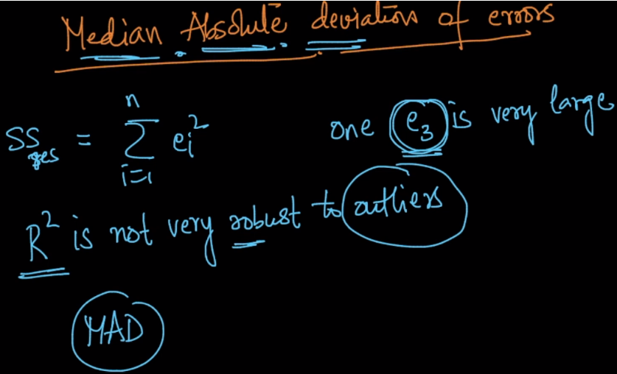

Now we first calculate errors for all the points, then find the median of errors and the MAD which defines the std dev for errors we get.

